***ST10497775***

**Fig 1 .** Shows The main Screen Where you have to insert your name then click the button

**Fig1.1** Shows A hello Message and a Brief Discription of the app and The Following Categories Football,History and IT(information Technology)

**Fig 1**

**Fig 1.1**

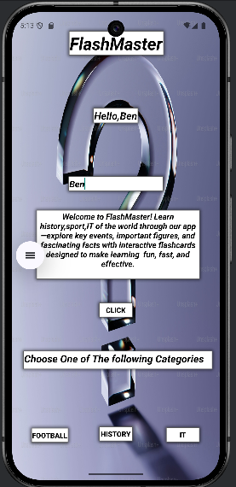

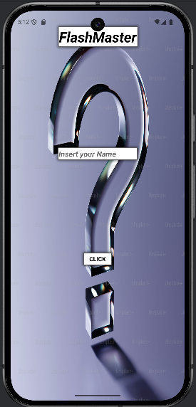

***FlashMaster Report***

**Fig 2.2**

**Fig 2.1**

**Fig 2**

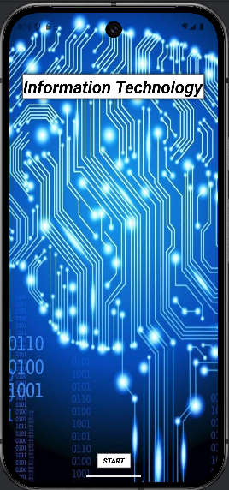

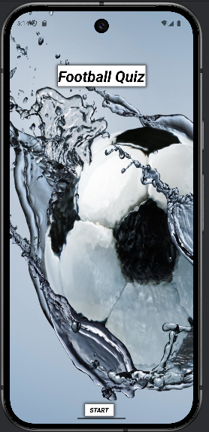

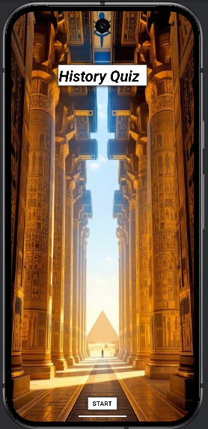

**Fig 3.1**

**Fig 3**

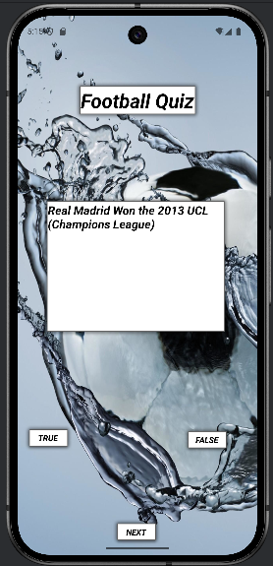

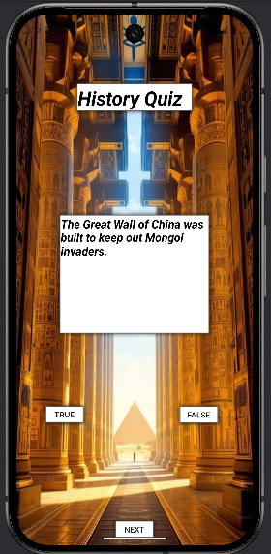

**Fig2** Shows the main Screen When You click on the history Option on the main Screen

**Fig2.1** Shows the main Screen When You click on the Football Option on the main Screen

**Fig.2.2** Shows the main Screen When You click on the It Option on the main Screen

**Fig3** Displays the question and the true or false buttons and the next button to move on the history screen

**Fig3.1** Displays the question and the true or false buttons and the next button to move on the football screen

**Fig.3.2** Displays the question and the true or false buttons and the next button to move on the It screen

**Fig 3.2**

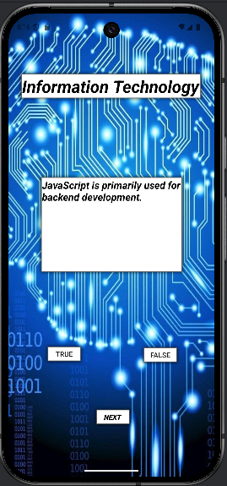

**Fig 5**

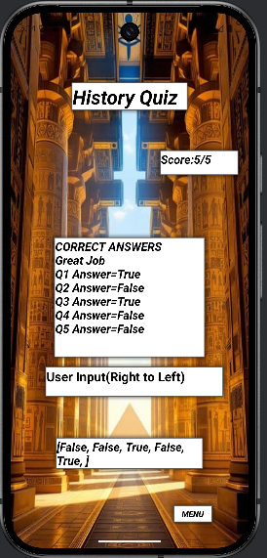

**Fig.4** Displays The Quiz When you Reach the End of The Question The Results Button appear To See How Well You Did

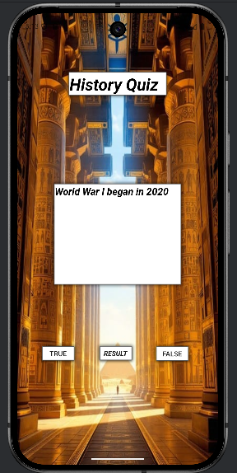

**Fig 4**

**Fig 5.3**

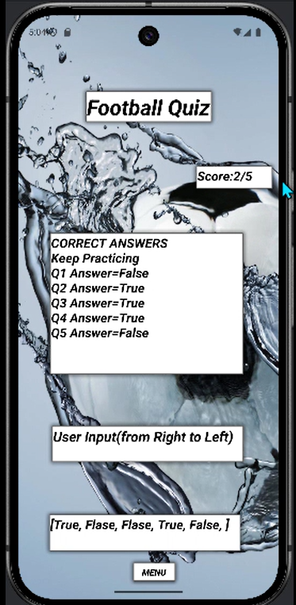

**Fig 5.2**

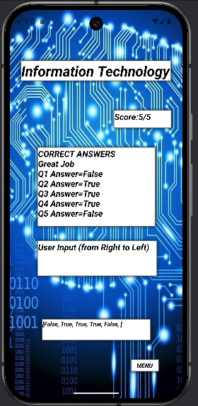

**Fig 5.1**

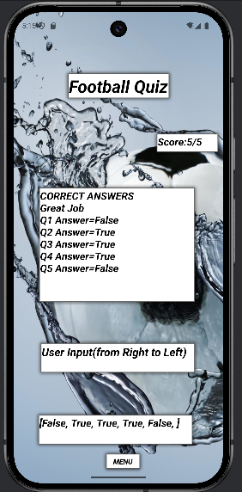

***Conclusion***

In conclusion, this report has provided a comprehensive overview of the FlashMaster app, covering its design, development, and functionality. Through detailed analysis and testing, we have demonstrated how the app effectively meets its intended objectives. Thank you for taking the time to read this report. Your feedback and insights would be greatly appreciated as they will contribute to the continuous improvement of the FlashMaster app.

**Fig5.** Displays your scrore once you click on the results button and below it comes the Correct answers to the questions with a customize text based on your score and your inputs below it and the menu button that allows you to go back to the main screen

**Fig5.1** Displays your scrore once you click on the results button and below it comes the Correct answers to the questions with a customize text based on your score and your inputs below it and the menu button that allows you to go back to the main screen

**Fig5.2** Displays your scrore once you click on the results button and below it comes the Correct answers to the questions with a customize text based on your score and your inputs below it and the menu button that allows you to go back to the main screen

**Fig 5.3** Is Just the same as the other ones in Fig.5 just Displaying another Text as you can see below the Correct Answers because of the score being low